Lab #1.2: Logistic Regression in Python

You’ll need two files to do this exercise: Lan 1.2.py (the Python script file) and Titanic.csv. Both of those files can be found on the Blackboard. The data file contains 715 passengers in the Titanic tragedy with demographic information and whether the passenger survived.

Download both files and save them to the folder where you keep your R files.

Part 1: Look at the Data File

- Open the Titanic.csv data file. You’ll see something like this:
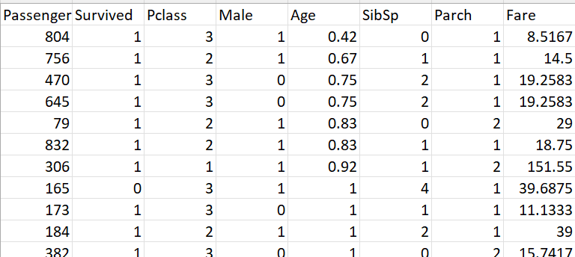
This is the raw data for our analysis. You can see the first variable (field) is called PassengerID, the second variable (field) is called Survived, the third variable (field) is called Pclass, and so on.

The remaining lines of the file contain the data for each passenger. So the ID for the first passenger is 804, the Survived for the first passenger is 1, the Pclass for the first passenger is 3, and so on.

This is a full list of the variables:
Variable Name | Variable Description
PassengerID | Passenger identification number
Survived | Whether a passenger survived or not: 0 = No, 1 = Yes
Pclass | Tick class: 1 = 1st, 2 = 2nd, 3 = 3rd
Male | Whether a passage is male: 1=male, and 0=female
Age | Age in years
sibsp | # of siblings / spouses aboard the Titanic
parch | # of parents / children aboard the Titanic
Fare | Fare of the ticket

Categorical outcome Variable: Survived (1 = did survive, 0 = did not survive).
We will use this data set to examine the association between whether a passenger survived and the remaining variables (i.e., Pclass, Age, Sex, etc.).
Some variables, like ID, are irrelevant to the analysis.
- Close the Titanic.csv file. If it asks you to save the file, choose “Don’t Save”.

Part 2: Explore the Lab1.2.py Script
- Open PyCharm.

- Open the Lab1.2.py file. Click-File. This contains the Python script that performs the logistic regression analysis.
- Look at lines 16 and 19. These define the input and output files. Here’s a rundown:

- Now let’s look at the simple logistic regression model with only one predictor. Scroll down to lines 30:
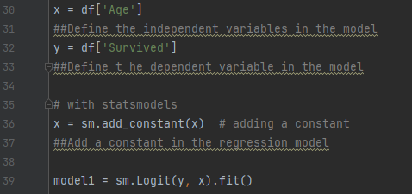
You can see a few things at work:

- The sm.logit() function is used to fit logistic regression models
- The formula for a simple logistic regression model is outcome ~ predictor1
- Survived is the outcome event
- Age is the explanatory or independent variable.

- Now let’s look at the multiple logistic regression model with more than one predictors. Scroll down to lines 49:
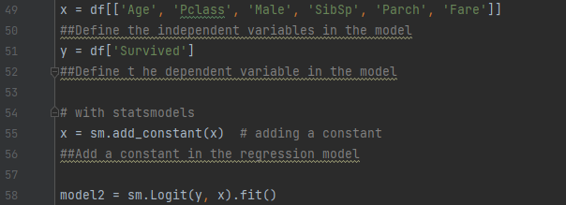
The only change compared to the previous one is that now we have more than one explanatory variable. Specifically, now we are looking at the correlation of not just Age, but also the Pclass, Male, sibsp, Parch, and Fare on people’s probability of being survived.

Part 3: Execute the Script
- Select Run/Run…/Select the File of your R script.
- It could take a few seconds to run. Be patient!

Part 4: Interpreting the Output
We fit a model to our data. That's great! Now we can look at the details of this fit with the summary function:

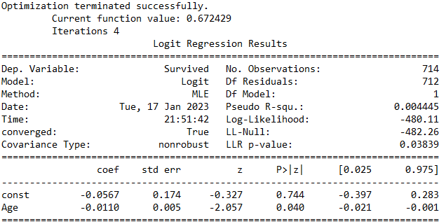
This output contains a lot of information. Let's look at a few parts of it.

- Briefly, it first shows the call that's the way that the function was called; Survived (y) explained by Age (x) using the mydata data. The regression equation we would like to fit would be $log-odds of being Survived=b_{0}+b_{1}Age$.

- This table, the most interesting part, is the coefficients- this shows the correlation of predictors and the significance of each.

- First, we have our estimate of the intercept ($b_{0}$): the estimated value of $b_{0}$ is -0.0567. Hypothetically, if we have a person with Age of 0, the predicted log-odds of being survived based on our logistic model would be -0.0567.

- Then we can see the effect of the Age variable on Survived ($b_{1}$): the estimated value of $b_{1}$ is -0.0110, which shows the effect of Age. This shows that there's a negative relationship, where increasing the Age decreases the probability of being survived. In particular, it shows that increasing the Age by 1 decreases the log-odds of being survived by -0.0110.

- So the table gives us the fitted regression line: $\hat{log-odds of being Survived} =-0.05672-0.01096Age$. You can then use this equation to predict the log odds of being survived for a person who has an Age of, say, 20.

Probability of being Survived=1/(1+exp(-($-0.0567-0.0110×20$)))

- This second column is called the standard error: we won't examine it here, but in short, it represents the amount of uncertainty in our estimate of the slope.

- The third column is the z-value of the coefficient estimate, a mathematically relevant value that was used to compute the last column, which is the p-value, describing whether this relationship could be due to chance alone. Smaller p-values (typically with p-value<0.10) indicates that the relationship is statistically significant.

- The Dispersion line is printed by default. We can ignore this.

Part 5: Try it yourself:
Looking at the results returned by model2.summary(), and try to interpret the output.

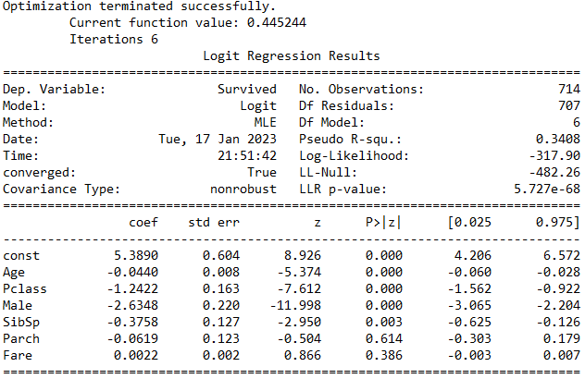
Questions:
(1) What is the dependent variable and what are the independent variables?

(2) How many observations are there in this dataset?

(3) What does the Intercept of 5.3890 mean?

(4) Which predictor variables are significantly correlated with Survived? Explain the coefficients of those variables.

(5) If your goal is to test the “effect” of age on people’s propensity to survive in Titanic, are there any other variables we should include in this model to avoid omitted variable bias? List 3 of them and explain your reasons.

(6) After you include the above three variables, do you think this model accurately tested the “effect” of age on people’s propensity to survive in Titanic? Why?

